Assignment #6 – Programming Part

**Code Location:**

**Question 1**

1. Mean Image:

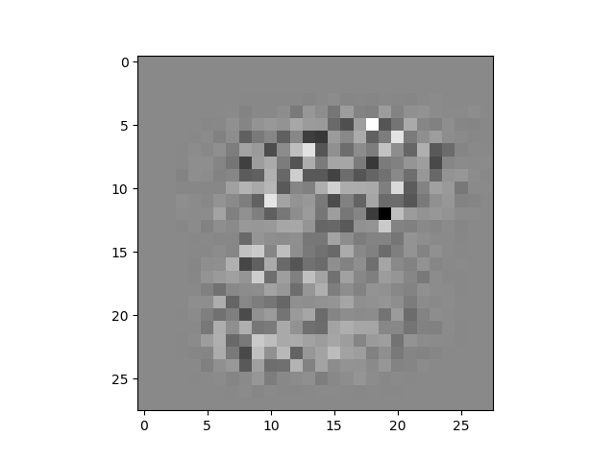

First 5 eigenvectors:

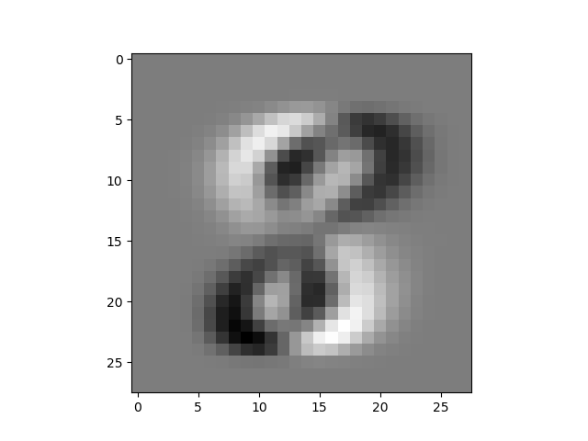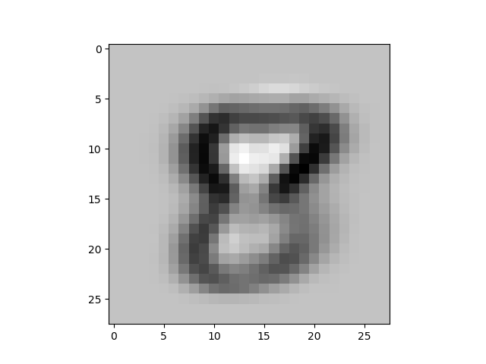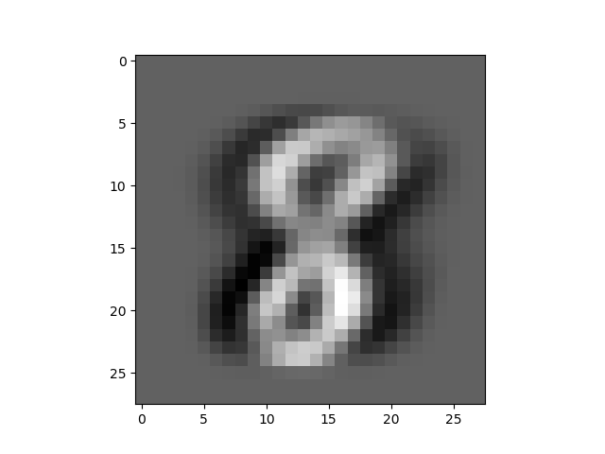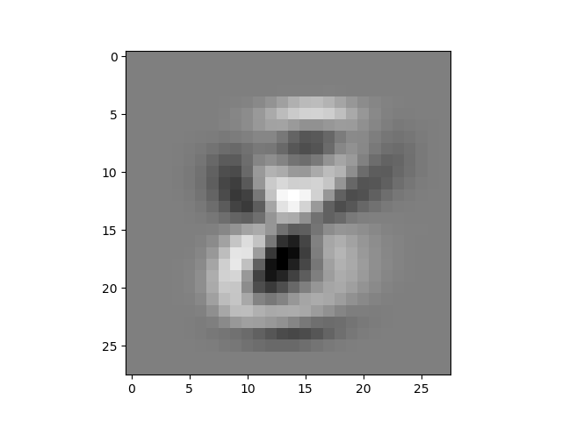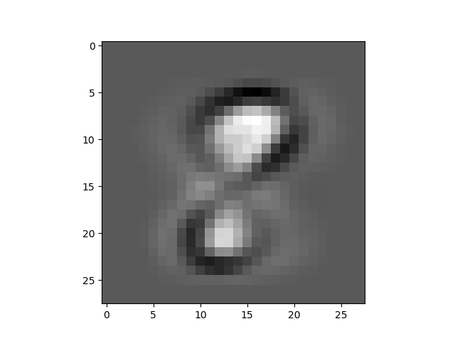

Eigenvalues (in decreasing order) as a function of dimension:

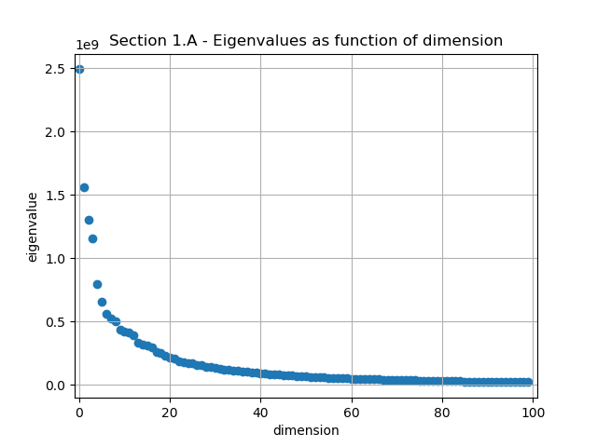

Explenations:

The first eigenvector looks like it determines if the digit is leaning to the left or right.

The second eigenvector looks like it determines if the digit has narrow or wide holes.

The third eigenvector looks like it determines the if the digit is thin or wide.

1. Mean Image:

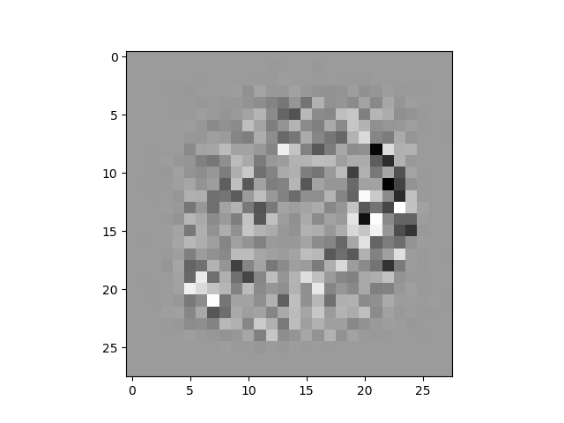

First 5 eigenvectors:

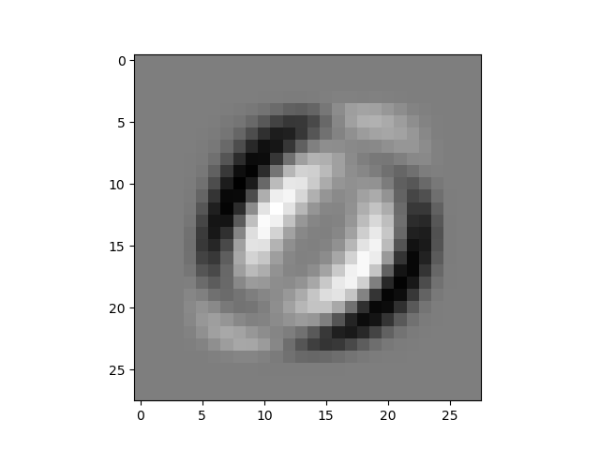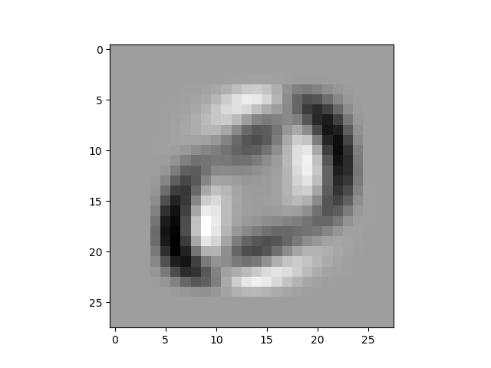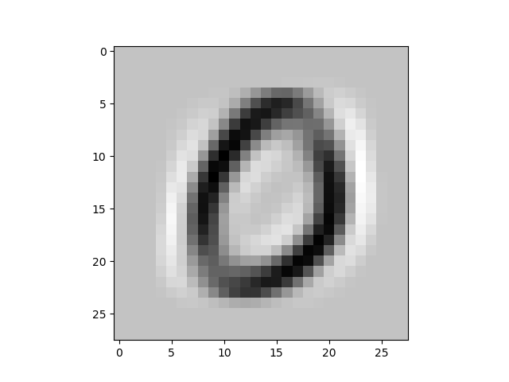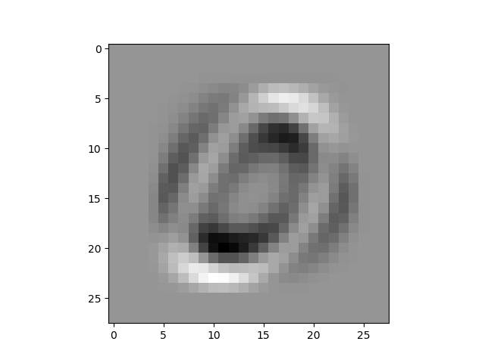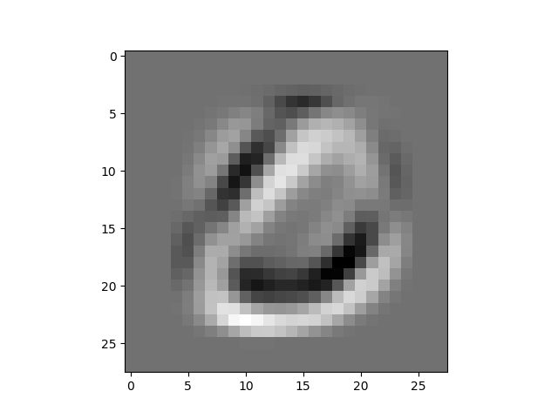

Eigenvalues (in decreasing order) as a function of dimension:

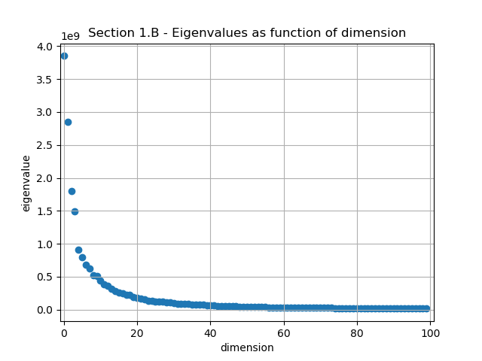

Explenations:

The first and second eigenvector looks like it determines if the digit is leaning to the right.

The third eigenvector looks like it determines the size of the digit.

1. We used only ~7000 samples of digits 0 and 8 for efficiency.